**Instructions for Predator-Prey Population Dynamics Code**

Population of prey in generation ***t***: **N(*t*)🡪 N(*t+1*)= N(*t*)*[1+B*(100-N(*t*))]-K* N(*t*)* P(*t*)**

Nmax=100 can be sustained by environment with limited resources, **kill rate= K**

Population of predator in generation ***t***: **P(*t*)🡪 P(*t+1*)= Q*N(*t*)* P(*t*)**, **Q=efficiency** of prey use

*Populations in relative units*.

Suggestions to explore dynamics with different parameters and initial conditions:  
a) N(0)= 60, 70

b) P(0)= 0.25, 0.3

c) B=0.0055, 0.0006, 0.00065

d) K= 0.25, 0.3, 0.19, 0.18

Which parameters may be changed slightly while maintaining a stable state of P & N?

Which parameters lead to population extinction or explosion?

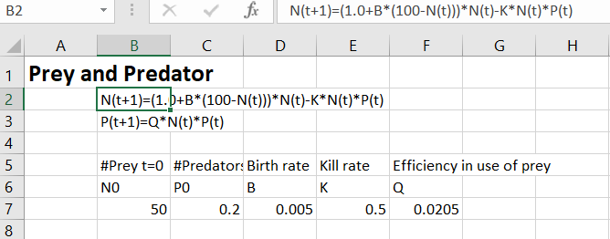

**This is used as 2 comment lines defining the equations to code**

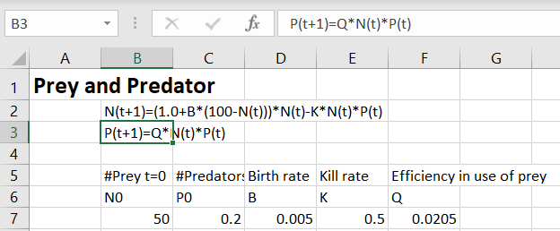

**This is used as 2 comment lines defining the equations to code**

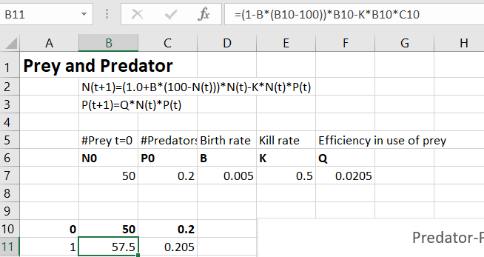

**Storage cells for naming and defining values of parameters used in program, change to explore different conditions**

**Initial populations, vary to see correlations!**

**Cells in column B have the formula for the iterative prey population**

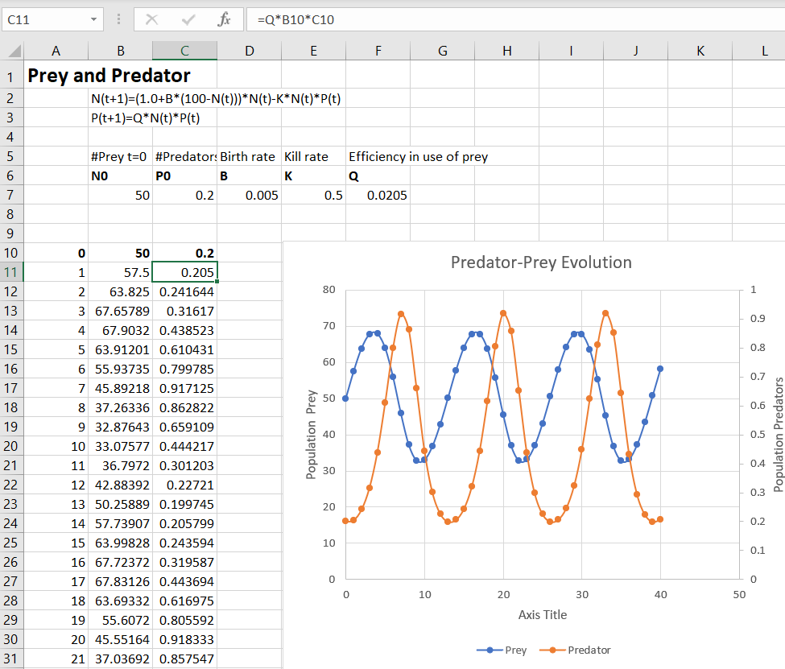

**Cells in column C have the formula for the iterative predator population**